🧾 Logging Levels



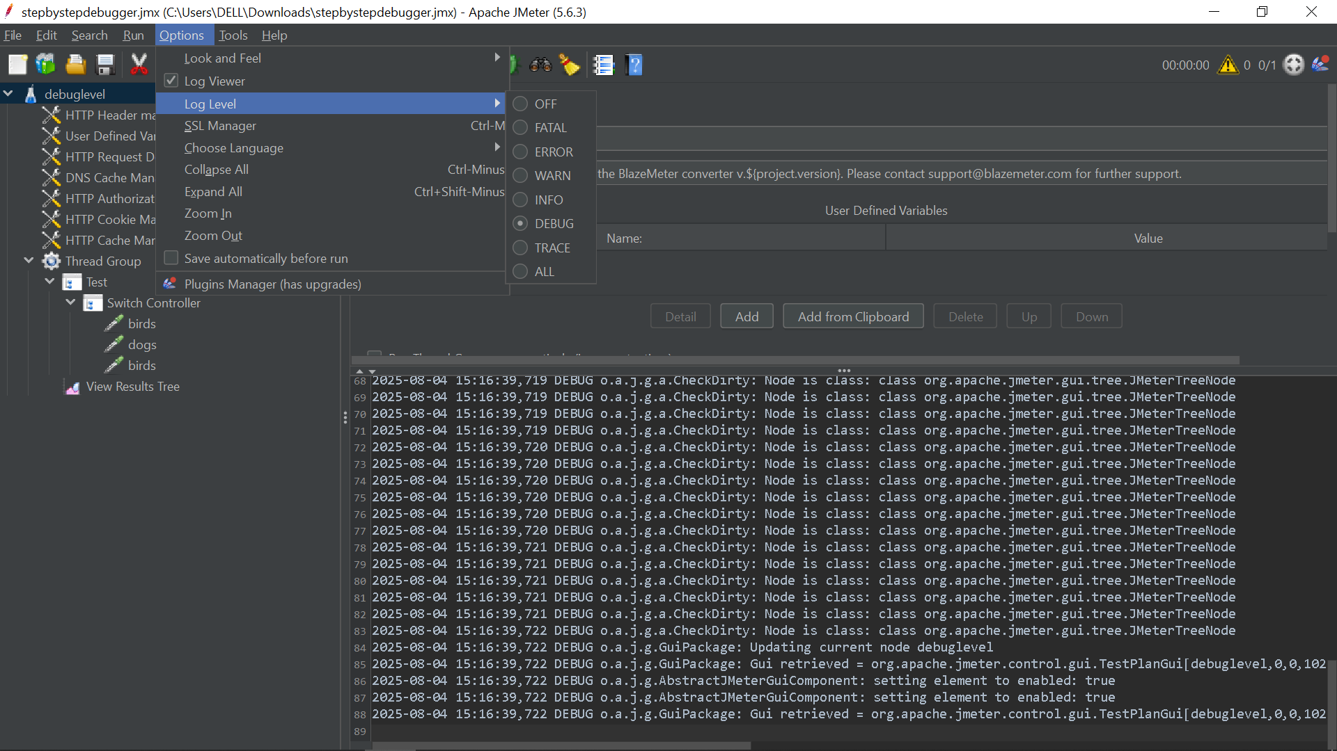

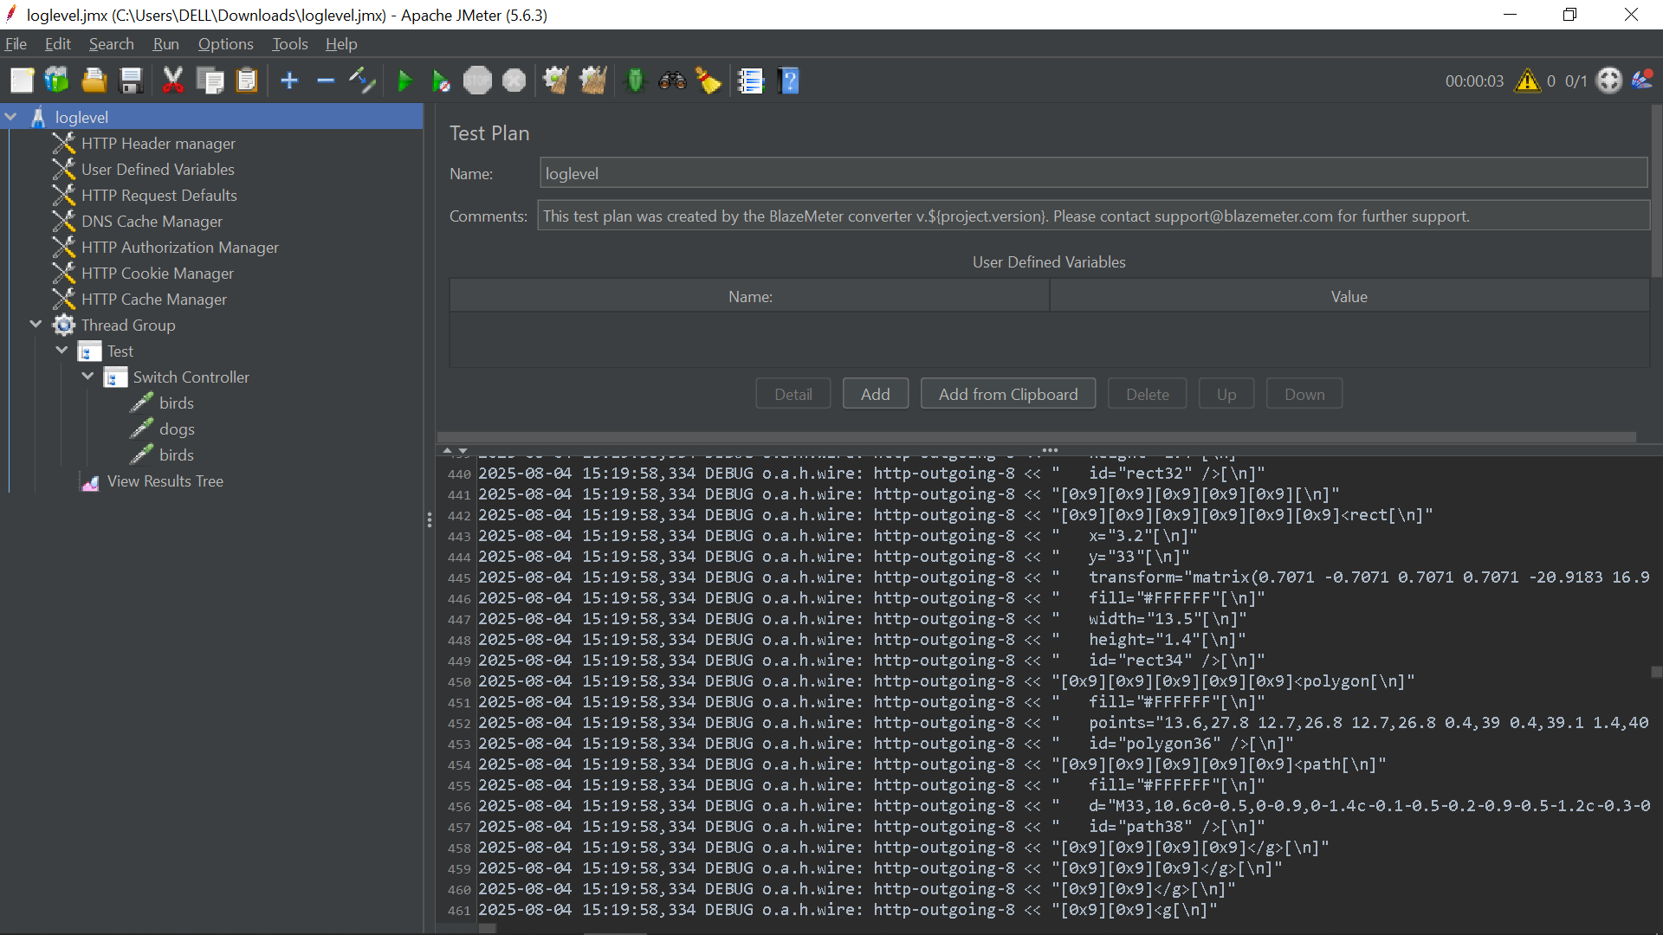

JMeter uses **Apache Log4j2** for logging, which allows detailed control over how much information is logged and where it's recorded.

**🔢 Standard Logging Levels in Order (Most to Least Severe)**

| **Level** | **Description** |
| --- | --- |
| OFF | Disables logging entirely. |
| FATAL | Critical problems likely to crash the application. |
| ERROR | Errors that let the test continue but indicate issues. |
| WARN | Warnings about potential issues. |
| INFO | High-level runtime information. |
| DEBUG | Detailed information useful for developers and debugging. |
| TRACE | Most detailed logging; includes fine-grained info on code execution. |
| ALL | Enables logging for all levels. (Not often used.) |

📌 **TIP:** Setting the level to INFO means JMeter will also show WARN, ERROR, and FATAL.

**⚙️ How to Configure Logging Levels**

**1️⃣ Using the GUI**

* Go to **Options → Log Level** to change the global logging level.
* To enable/disable debug logs for a specific component:
  + Select the component.
  + Use **Help → Enable Debug** or **Help → Disable Debug**.

**2️⃣ Using log4j2.xml**

* Located in the bin/ directory.
* You can configure **log levels per package/class**.

**Example:**

xml

CopyEdit

<Logger name="org.apache.jmeter.protocol.http" level="DEBUG" additivity="false">

<AppenderRef ref="jmeter-log" />

</Logger>

* Set the global log level via:

xml

CopyEdit

<Root level="INFO">

<AppenderRef ref="jmeter-log"/>

</Root>

**3️⃣ Using the Command Line**

When running in **non-GUI mode**:

bash

CopyEdit

jmeter -n -t my_test.jmx -l results.jtl -L[category]=[level]

**Examples:**

* Set global level to DEBUG:

bash

CopyEdit

jmeter -n -t test.jmx -l result.jtl -LDEBUG

* Debug HTTP sampler only:

bash

CopyEdit

jmeter -n -t test.jmx -l result.jtl -Lorg.apache.jmeter.protocol.http=DEBUG

**4️⃣ Using jmeter.properties (Limited Use)**

Located in the bin/ directory.

* Example setting:

properties

CopyEdit

jmeter.loggerpanel.display=true

This controls whether the **GUI log panel** is shown at launch.

**📍 Where to View Logs**

| **Log Location** | **Description** |
| --- | --- |
| **GUI Log Viewer** | Found under Options → Log Viewer or via top-right icon. |
| **jmeter.log file** | Located in bin/. Default file for GUI & non-GUI log output. |

**✅ Best Practices**

| **Scenario** | **Recommended Log Level** | **Notes** |
| --- | --- | --- |
| Scripting & Debug | DEBUG or TRACE | Helps track variables, functions, and logic. |
| Load Testing | INFO or WARN | Minimizes CPU/disk impact to ensure valid performance results. |
| Component Focused | Use log4j2.xml for granular control | Example: Only enable DEBUG for HTTP sampler. |

**🧠 Quick Recap**

* Use DEBUG when building, INFO when executing performance tests.
* Prefer **component-level debugging** via log4j2.xml over global changes.
* Avoid TRACE in production runs—can overwhelm logs and skew metrics.

Let me know if you’d like:

* A ready-to-edit sample log4j2.xml template.
* Examples of how logging can help debug failed correlations or variables.
* A one-liner command to toggle log levels quickly on demand.